





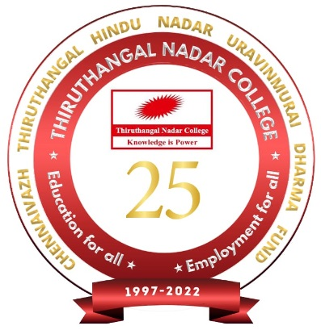

**THIRUTHANGAL NADAR COLLEGE**

**(Belongs to the Chennaivazh Thiruthangal Hindu Nadar Uravinmurai Dharma Fund)**

**A Self Financing Co-Educational College of Arts & Science**

**Affiliated to University of Madras**

**Accredited with ‘B’ Grade by NAAC &an ISO 9001:2015 Certified Institution**

**Selavayal, Chennai, Tamil Nadu, India**



**KNOWLEDGE ENHANCEMENT PROGRAMME**

***on***

**NANOMATERIALS AND APPLICATIONS**

***organized by***

**THE DEPARTMENT OF CHEMISTRY**

***in association with***

**INTERNAL QUALITY ASSURANCE CELL (IQAC)**

**Certificate of Appreciation**

**This is to certify that Mr. / Ms. / Dr.S. MURUGANANDAM, ASSOCIATE PROFESSOR of MEENAKSHI COLLEGE OF ENGINEERING, CHENNAI has served as resource person in the KNOWLEDGE ENHANCEMENT PROGRAMME on “NANOMATERIALS AND APPLICATIONS” on 30/03/2022.**

**XXX Dr.S.SRIVIDHYA THIRU.M.G.E.SELAPALAM**

**HOD PRINCIPAL SECRETARY& CORRESPONDENT**

**TNC– IQAC/31/2021-2022**